CS 7646 – Project 8 Strategy Evaluation

Guangqing Tai  
[gtai3@gatech.edu](mailto:gtai3@gatech.edu)

Note: this is a re-submission of previous ML4T work, which may contain repeated sentences.

# Introduction

CS 7646 – Project 8 Strategy Evaluation Report aims to evaluate and compare manual trading strategies, which leverage predefined stock market indicators such as SMA and Bollinger Bands, with machine learning-based strategies, including Random Forest and Q-Learning. The goal is to analyze their effectiveness in predicting market movements and creating optimal trading plans that maximize return on investment while addressing key challenges like overfitting and adaptability to new data.

# Indicator overview

Three key indicators from Project 6 were selected for this implementation: Bollinger Bands, Relative Strength Index (RSI), and Average Directional Index (ADX). These indicators were chosen for their ability to capture different aspects of market behavior—volatility, momentum, and trend strength—providing a comprehensive foundation for both manual and learner-based trading strategies.

## Bollinger Bands

Bollinger Bands are a widely used volatility indicator designed to identify overbought and oversold conditions in the market. They consist of three components: the middle band, which represents a simple moving average (SMA) of the security's price, and the upper and lower bands, typically set two standard deviations above and below the middle band. In this implementation, Bollinger Bands are calculated using a 20-day SMA. Both the Manual Strategy and Strategy Learner optimize parameters such as the lookback period for the SMA (default: 20 days) and the number of standard deviations (default: 2). By identifying instances when the price deviates significantly from the average, Bollinger Bands signal potential buy or sell opportunities, making them an integral part of the trading strategy.

## RSI

The Relative Strength Index (RSI) is a momentum oscillator that evaluates the speed and magnitude of recent price changes to identify overbought or oversold conditions. It operates on a scale from 0 to 100, with an RSI above 70 indicating an overbought security and an RSI below 30 signaling an oversold security. In this implementation, RSI is calculated using a default 14-day period. The primary parameter optimized is the lookback period, which determines the number of days used in the calculation. In both the Manual Strategy and Strategy Learner, an RSI below 30 serves as a buy signal, while an RSI above 70 indicates a sell signal, making it a vital component for identifying market reversals.

## ADX

The Average Directional Index (ADX) is a trend strength indicator that ranges from 0 to 100, with values above 20 generally indicating a strong trend. The ADX is derived from the Directional Movement Index (DMI), which comprises two components: the Plus Directional Indicator (+DI) and the Minus Directional Indicator (-DI). For this implementation, the ADX is calculated using a default 14-day period. The key parameter optimized is the lookback period, which impacts the calculation of +DI, -DI, and ADX values. In both the Manual Strategy and Strategy Learner, an ADX above 20 is used in conjunction with other indicators to confirm the presence and strength of a market trend, enhancing the reliability of trading signals.

# Procedural elements

## Manual Strategy Implementation

In the Manual Strategy, all three indicators—Bollinger Bands, RSI, and ADX—are combined to generate Buy and Sell signals based on predefined conditions:

* **Bollinger Bands**: A buy signal is generated when the price is below the lower band, and a sell signal is generated when the price is above the upper band
* **RSI**: A buy signal occurs when the RSI is below 30, and a sell signal occurs when the RSI is above 70
* **ADX**: A confirmation is sought with an ADX value above 20 as a strong trend

The strategy operates as follows:

* When the price is below the lower Bollinger Band, RSI is below 30, and ADX is above 20, a buy action is triggered.
* When the price is above the upper Bollinger Band, RSI is above 70, and ADX is above 20, a sell action is triggered.
* If the price is above the upper band, RSI exceeds 70, and ADX is below 20, the long position is exited by selling.
* Similarly, if the price is below the lower band, RSI is below 30, and ADX is below 20, the short position is exited by buying back.

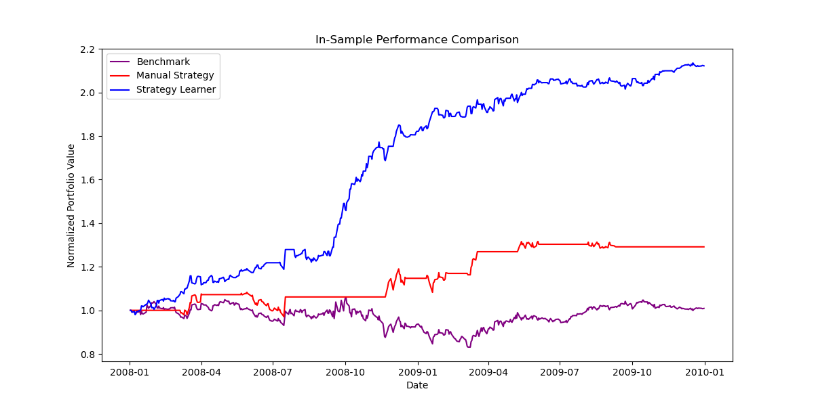This strategy aims to capitalize on key reversal points and strong market trends by taking aggressive actions at optimal moments. The use of three complementary indicators reduces the risk of false signals compared to relying on a single indicator. Bollinger Bands identify extreme price levels, RSI confirms momentum, and ADX verifies trend strength. Together, they provide a comprehensive view of market conditions, ensuring that trading decisions consider not just price levels but also market momentum and trend dynamics. This multi-faceted approach enhances the reliability of the strategy and effectively identifies overbought and oversold conditions for optimal trading actions.

**Figure 1 In-sample Performance comparison for 3 different strategies**

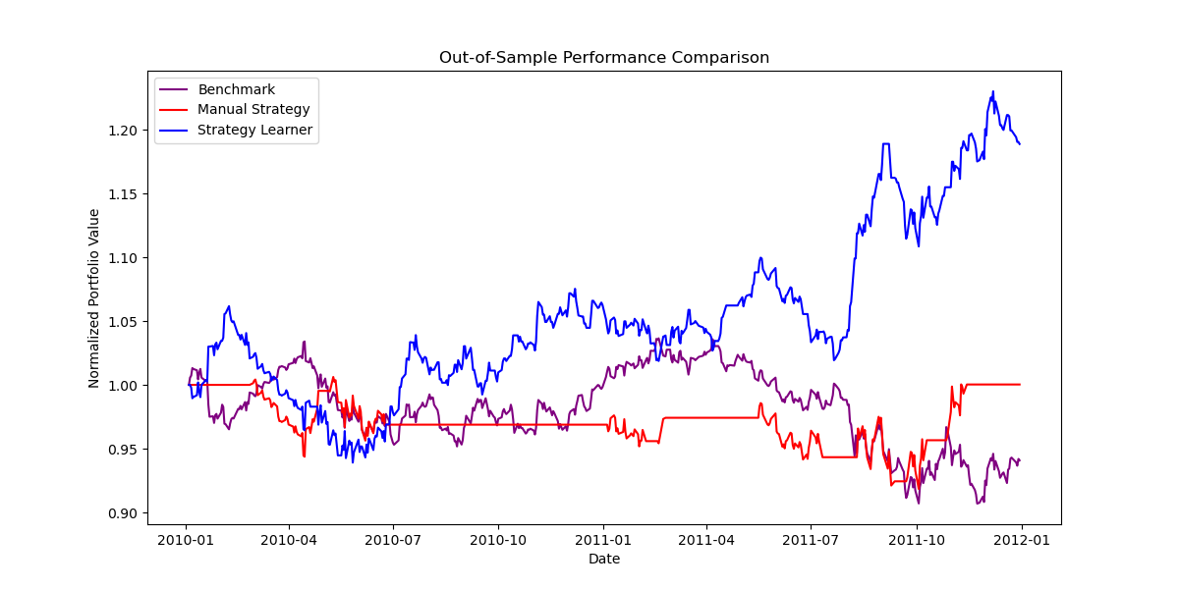As shown in Figures 1 and 2, the purple lines represent the Benchmark strategy, which involves buying 1000 shares at the start and holding them throughout. The red lines represent the Manual Strategy, which uses Bollinger Bands, RSI, and ADX to actively buy or sell 1000 shares based on the predefined trading rules.

**Figure 2 Out-of-sample performance comparison of 3 different strategies**

The Benchmark strategy follows a passive trend aligned with market movement, as no actions are taken after the initial purchase. In contrast, the Manual Strategy exhibits aggressive trading behavior, resulting in higher average returns compared to the Benchmark strategy. This is evident in both in-sample and out-of-sample data, which cover different time periods with distinct market movement patterns.

When comparing the in-sample and out-of-sample results for the Manual Strategy, similar trends are observed, but the in-sample period shows slightly better performance. This difference is not due to the Manual Strategy itself, as its rules are consistent across periods, but rather due to differences in market conditions. The in-sample period features steadier market movements, which align well with the Manual Strategy's aggressive trading actions. Conversely, the out-of-sample period includes more frequent market fluctuations, which reduce the effectiveness of the 'ideal' conditions assumed by the strategy, leading to slightly lower returns

.

## Strategy Learner Implementation

The Strategy Learner uses the same indicators as the Manual Strategy but employs a machine learning approach to optimize trading decisions. It leverages these indicators as features and price changes as the target variable to train a Random Tree (RT) model. The implementation involves the following steps:

* **Data preparation**: Data discretization is conducted to converting continuous data into binary (i.e. converting historical stock price change into target); standardization is also used to each feature (indicators) so they will be measured on a similar scale, which prevent any single feature form dominating the learning process.
* **Feature Engineering**: The 3 indicators serve as features for the Random Tree (RT) model and the leaner collects data points of those indicators within the training date period.
* **Hyperparameters**: Leaf size is one of the key hyperparameters for RT learner, which determines the minimum number of samples required to form a leaf in decision tree. Here I set 10 as the minimum on a balance between model complexity and generalization ability. A smaller leaf size would make the model more sensitive to noise in the training data, while larger size might oversimplify the model.
* **Financial parameters:** impact represents the market impact cost, simulating the effect of a trade on the stock price; and commission is the fixed cost for each transaction. In this practice, both parameters are set as zero to stress-test the optimal without those.
* **Training**: The learner will use those features and target (next day price>today price=1, next day price<today price=0) along with RT learner to predict future price movements and determine the best trading actions.
* **Optimization**: The lookback periods and thresholds for the indicators are implicitly optimized through the training process, as the learner adjusts to maximize the predictive accuracy based on historical data.

# Experiments

## Experiment1

Experiment1 will be discussed based on Figure 1 and Figure 2 above.

In the first experiment, three strategies—Benchmark, Manual Strategy, and Strategy Learner—were evaluated using historical stock data for JPM from 2008-01-01 to 2011-12-31. For this analysis, transaction costs and market impact were excluded to focus purely on strategy performance.

The hypothesis was that the Strategy Learner, trained on historical data, would identify stock movement patterns and predict future prices effectively for both in-sample and out-of-sample data.

For the in-sample period (2008-01-01 to 2009-12-31), the Strategy Learner demonstrated a significant increase in portfolio value, as expected. This performance reflects the model's ability to leverage historical patterns it was trained on, effectively optimizing its decisions for this period. The Benchmark strategy, as discussed in Section 3.1, aligns passively with market trends, while the Manual Strategy exhibits more active trading behavior, resulting in moderate gains between the other two strategies.

The Strategy Learner performs exceptionally well in the in-sample period because it is specifically tuned on this data. During training, the model optimizes its parameters to fit historical patterns in the in-sample data, which allows it to make highly effective decisions in this context. This explains the significant portfolio growth during the in-sample period. However, this tuning introduces the risk of overfitting, as the model may learn specific patterns unique to the training data that do not generalize to new, unseen data. In the out-of-sample period, the Strategy Learner encounters a more complex and volatile environment, which highlights its limitations in adapting to unfamiliar market conditions. Despite this, the Strategy Learner still outperforms both the Manual Strategy and the Benchmark, showing its ability to generate returns even under less favorable circumstances.

Despite these limitations, the Strategy Learner shows a modest improvement in portfolio value at the beginning of the period and achieves a final result of approximately a 20% increase. While this is a strong performance compared to the Benchmark and Manual Strategy, it falls short of its in-sample final result, which showed an increase of approximately 120%. This discrepancy underscores the inherent difficulty of translating in-sample optimization to out-of-sample robustness, particularly in dynamic and unpredictable market conditions.

In conclusion, this experiment highlights the strengths and weaknesses of both strategies (excluding the Benchmark). While the Manual Strategy is straightforward and less flexible, it proves effective across varying conditions with minimal effort. The Strategy Learner, though powerful in steady environments, is more sensitive to changes in market dynamics and requires additional effort for training and validation. These findings underscore the need for careful tuning and evaluation when deploying machine learning-based strategies in real-world scenarios.

## Experiment2

Experiment 2 examines how varying impact values influence the Strategy Learner’s (RT Learner) trading behavior and performance. The hypothesis is that the strength of market impact will affect the frequency of trades and overall returns.

* **Higher Impact**: A higher impact value increases the perceived cost of making transactions, leading to more cautious trading behavior. The strategy avoids less profitable trades to minimize transaction costs, resulting in fewer trades and lower returns.
* **Lower Impact**: Conversely, a lower impact value reduces the perceived transaction cost, encouraging more frequent trading. While this can lead to higher returns if trades are successful, it also increases the risk of overtrading, where frequent but less profitable trades erode overall performance.

For this experiment, the same in-sample data as Experiment 1 is used, covering the period from 2008-01-01 to 2009-12-31. The out-of-sample data spans 2010-01-01 to 2011-12-31. Three impact values—0.0, 0.1, and 0.2—are tested to evaluate their effects. The features are based on the three selected indicators, and the target variable is binary: 1 if tomorrow’s price is greater than today’s price, and 0 otherwise.

The Strategy Learner is trained on the in-sample data, and its performance is validated on both in-sample and out-of-sample data. Portfolio values over time are calculated for each impact value, providing insight into how trading behavior adjusts in response to different levels of transaction costs.

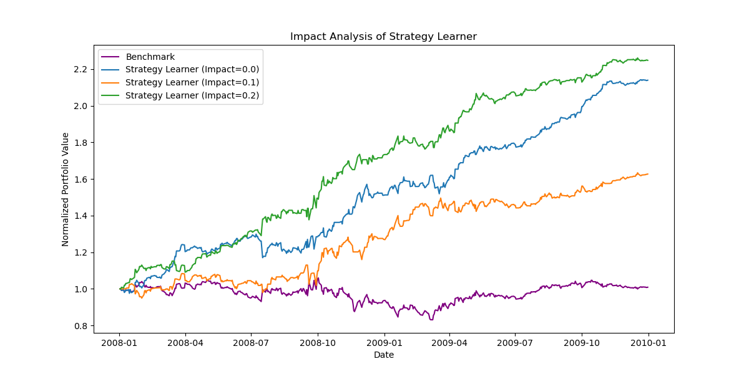Trained in-sample model output will be applied to validation in-sample data, and a portfolio value over a time period will be calculated for each impact value.

**Figure 3 Impact analysis for strategy learner**

Figure 3. highlights how varying impact values influence the Strategy Learner’s trading behavior and portfolio performance. When the impact value is set to 0, the Strategy Learner executes trades aggressively, unconstrained by transaction costs. This allows it to capitalize on small profit opportunities frequently, resulting in the highest portfolio value by the end of the period. However, as transaction costs are introduced and increase to 0.1 and 0.2, the Strategy Learner adjusts its strategy by becoming more selective in its trading decisions. This more cautious approach reduces the frequency of trades, ensuring that only high-confidence opportunities are pursued. Consequently, while the portfolio value still grows steadily, the final returns are lower compared to the zero-impact scenario.

Even with an impact value of 0.2, where transaction costs are highest, the Strategy Learner achieves a significant increase in portfolio value, outperforming the Benchmark strategy. The Benchmark, which involves passively holding 1000 shares throughout the period, reflects steady but minimal growth, highlighting its inability to adapt to market dynamics or exploit trading opportunities. The consistent outperformance of the Strategy Learner across all impact values demonstrates its robustness and ability to mitigate the effect of rising costs by prioritizing profitability over trading frequency.

This analysis underscores the critical trade-offs between trading aggressiveness and transaction costs. While lower impact values yield higher returns through frequent trading, they also carry the risk of overtrading, which may erode performance if the trades are not consistently profitable. On the other hand, higher impact values encourage a more cautious trading approach, which, while leading to lower returns, ensures that fewer resources are wasted on marginal opportunities. The adaptability of the Strategy Learner to varying cost environments is a key strength, showcasing its ability to optimize performance even under constraints that would typically hinder more rigid trading strategies.